- COMPLETION REPORT SUBMITTED NOT MORE THAN SIX MONTHS AFTER PROJECT COMPLETION

Date submitted to AFB secretariat: 10th February 2021
Implementing Entity: Agency for Agricultural Development (ADA)
Country: Morocco
Adaptation Fund Grant I.D:
Grant Type: TA-ESGP
Project Description/Project Title: Technical Assistance to support the compliance of ADA with the Adaptation Fund’s and others international donors Environmental and Social policy and Gender policy
Project Sector: institutional capacity building

Activity | Expected Outcome | Outcome Achieved/Not Achieved | Comment/Explanation  (also explain any deviation from initial plan)
Gender Policy | Prepare a gender gap assessment and  Support the implementation, monitoring and evaluation of the gender action plan | Achieved | This activity concerned the:  - Preparation of a gender gap assessment against AF’s gender standards and other best international practices to improve ADA’s gender policy, and prepare the action plan to fill the identified gaps  - Support the implementation, monitoring and evaluation of the gender action plan
Environmental and Social Policy | Prepare an environmental and social risk management’s action plan including the commitment and capacity to assess and respond to the environmental and social risks when dealing with all the adaptation projects/programmes, as the ones supported by the AF and in light of its ESP (in terms of(i) the possible mitigation measures to adopt during implementing, and (ii) monitoring and reporting on the status of those measures during and at the end of implementation)  ADA will do one consultation for those activities with a firm providing both a gender and ESS experts. | Achieved | This activity concerned the preparation of an environmental and social risk management’s action plan including the commitment and capacity to assess and respond to the environmental and social risks when dealing with all the adaptation projects/programmes, as the ones supported by the AF and in light of its ESP (in terms of(i) the possible mitigation measures to adopt during implementing, and (ii) monitoring and reporting on the status of those measures during and at the end of implementation)
Training Session | This activity includes training sessions for ADA’s team to enhance their capacities regarding the gender & ESS action plan targeted and that for the implementation of projects financed by the AF | Achieved | training session (3 days) have been carried out for the benefit of ADA’s staff (approximately 15 people). Its objective is been to brief the beneficiaries on the international context of this policy and to train them for its implementation (see photos below)  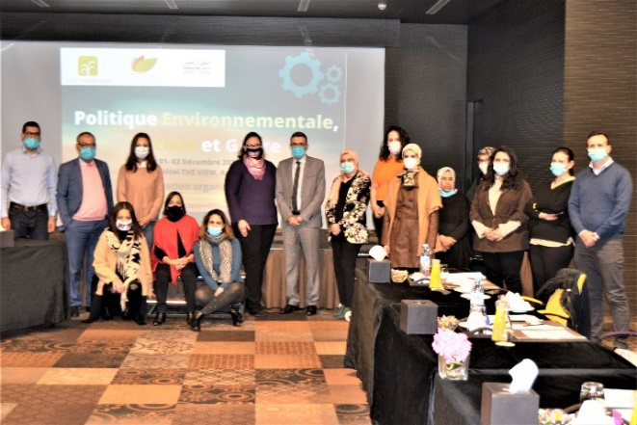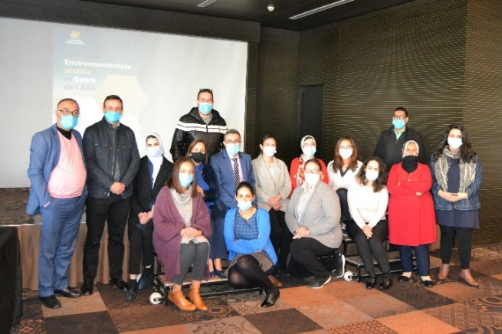
Budget | State whether overall expenditure was over or under the planned budget and give brief explanation for deviations of more than 30%.
Summary of overall outcome including any challenges faced and how they were resolved, and an explanation of how achieved outcomes will be disseminated or taken forward*. | Within the framework of the Adaptation Fund Readiness for technical assistance for the Assessment of Environmental, Social and Gender Risks, ADA has launched a consultation for the recruitment of technical assistance for the development of the environmental and social safeguard policy and the gender policy.  The ALLIADEV consulting firm was selected to implement this mission (firm providing both a gender and ESS experts). The two consultants Meryem Houzir and Mouna Lyoubi led the mission with success.  This mission mainly aimed to update the environmental and social policy drawn up by the ADA in 2015 and the ADA gender policy.  The mission is broken down into two phases:  - Phase 1: diagnosis, analysis, policy formulation and action plan; from 29 July to 28 august 2020  During this step, AlliaDev carried out a national and international benchmark in order to identify other initiatives and experiences of environmental and social policy developed by organizations accredited by the FA or other climate donors in Morocco, Africa / Maghreb and possibly structures involved in the agricultural sector.  - Phase 2: Implementation: From 11th November 2020 to 10th December 2020  In the phase 2, training session (3 days) have been carried out for the benefit of ADA’s staff (approximately 15 people). Its objective is been to brief the beneficiaries on the international context of this policy and to train them for its implementation.
Any feedback/general comment to the AFB secretariat | As the budget needed to hire the consultants for those activities was lower than projected, and as ADA have benefited from an exemption for value added tax, so ADA would like to use remaining funds to support one activity related to training session for ADA’s statf that have not been involved in the 1st training session (as the number was limited to 15) and they are also involved on the implementation of the ESP & Gender policies within the framework of the projects conception and supervision.  In this regard, ADA expresses highly its interest to reallocate the remaining funds.
*If there have been any delays in project implementation that affected project completion dates, state the reasons for the delays.

Contact Person: Meryem ANDALOUSSI Email: meryem.andaloussi@gmail.com

